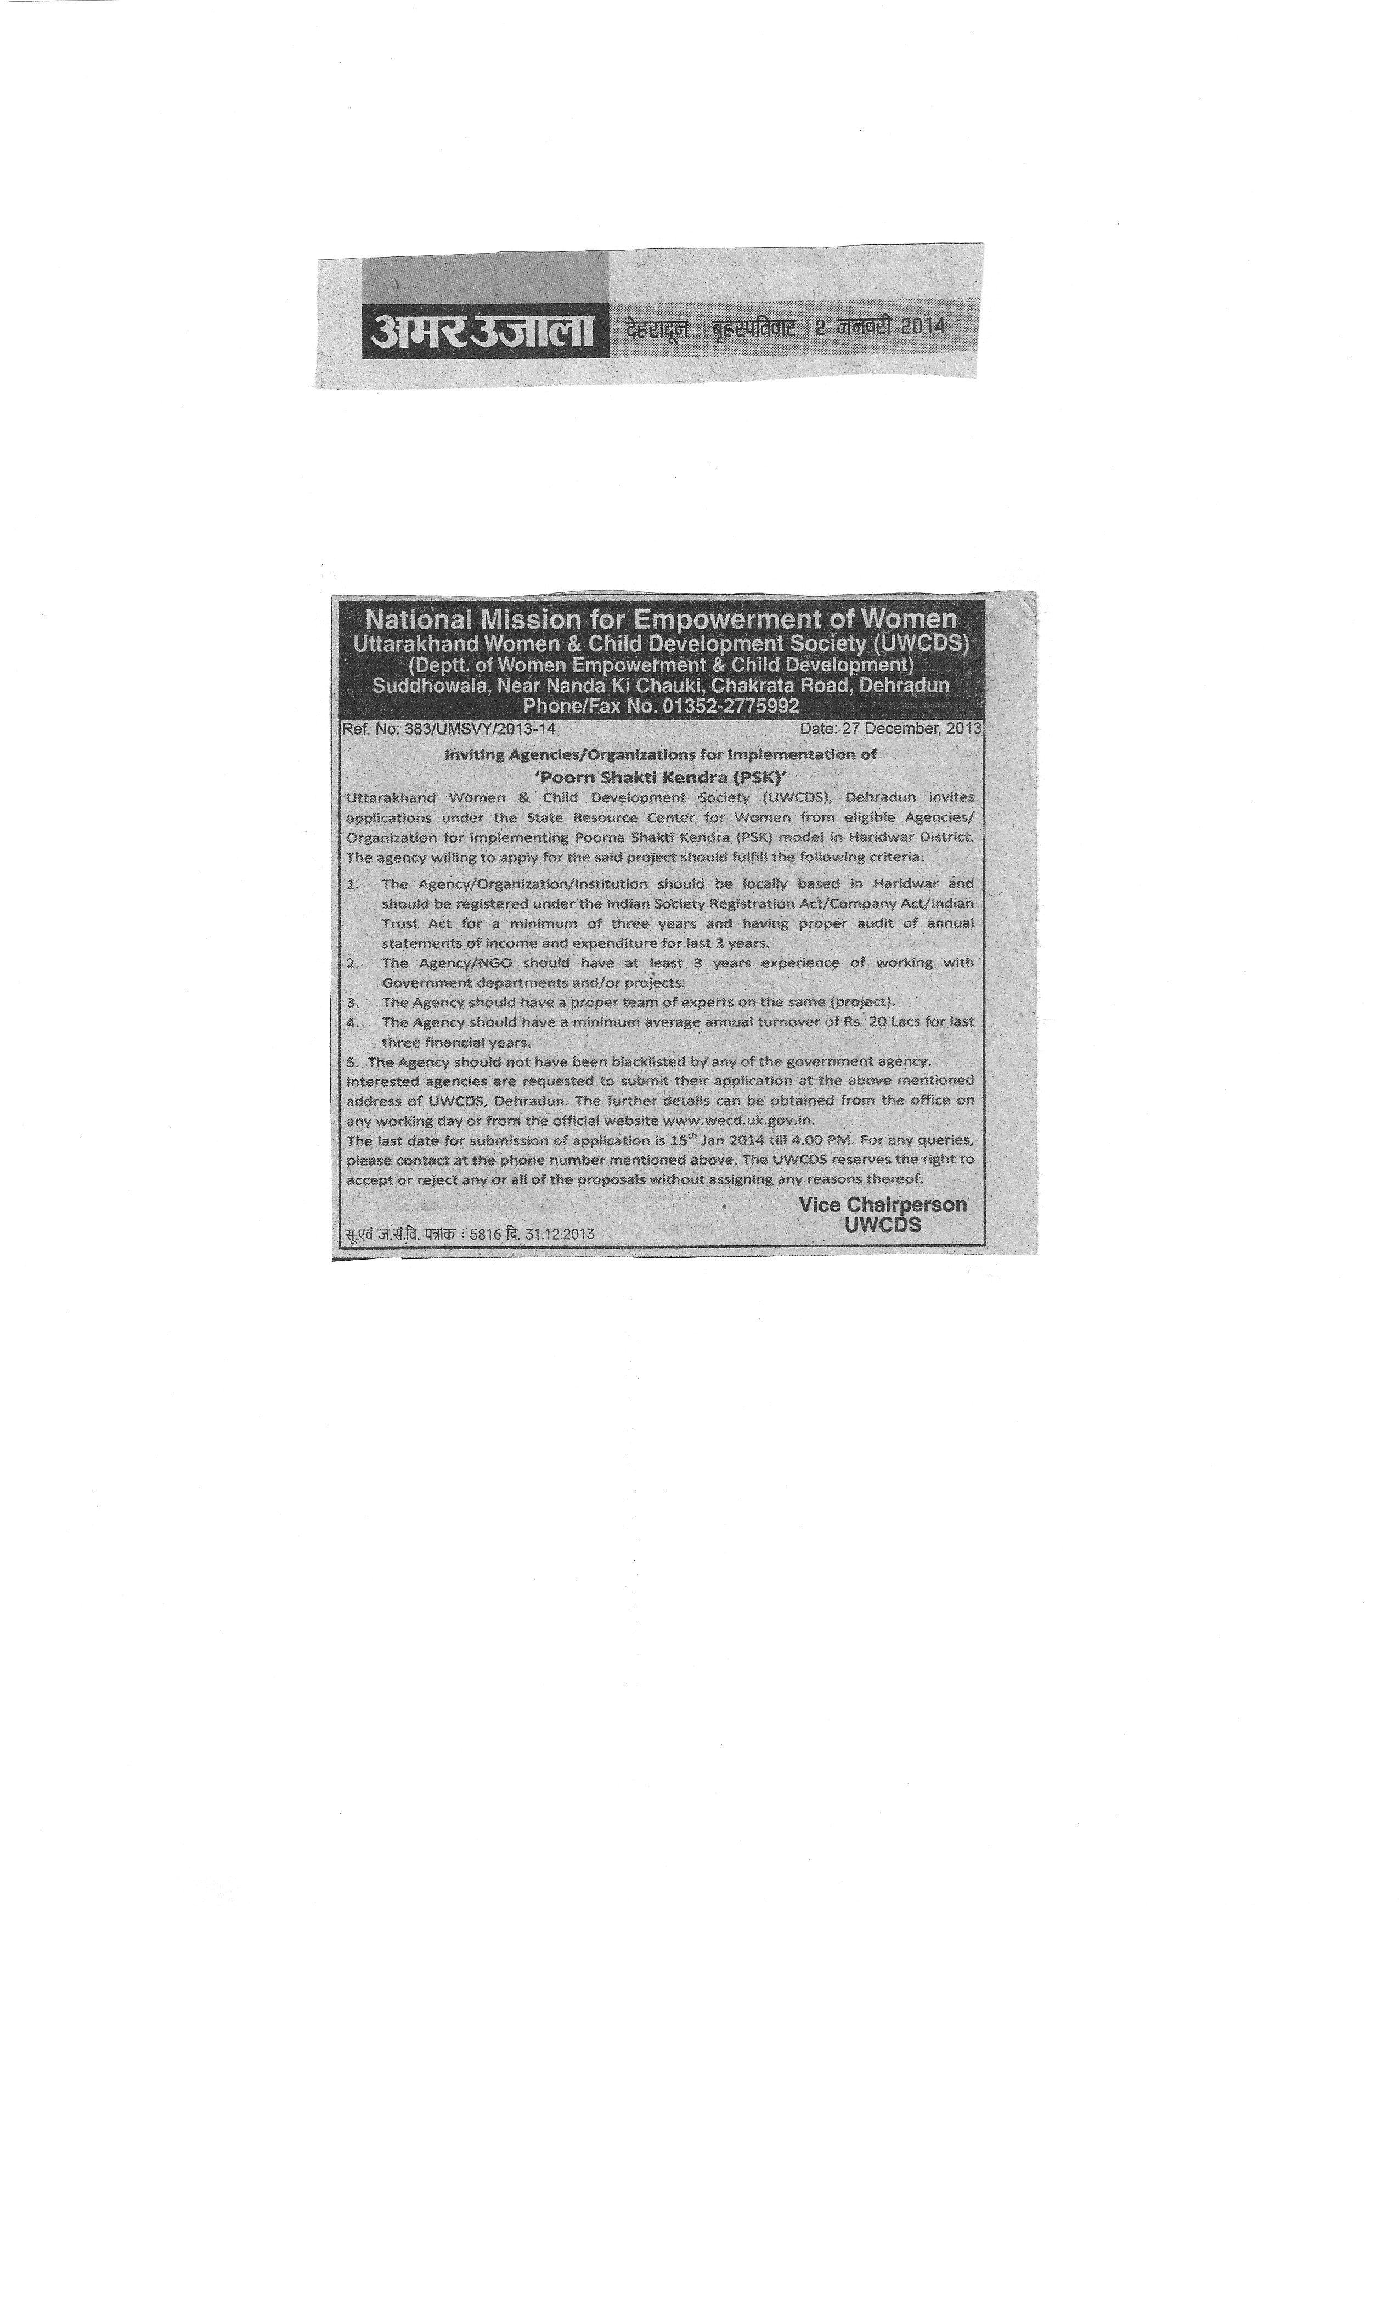
NATIONAL MISSION FOR EMPOWERMENT OF WOMEN
POORNA SHAKTI KENDRA (PSK)

Background

‘Hum Sunenge Naari Ki Baat’ (we shall listen to women) would be the new motto of a women empowerment project to be implemented in district Haridwar of Uttarakhand. The project– Poorna Shakti Kendra (PSK) Model –will be implemented as a pilot project under the National Mission for Empowerment of Women. The Poorna Shakti Kendra (PSK) is the focal point of action on ground through which the services to women at grass root level would be facilitated. Poorna Shakti Kendra will be implemented in 10 Gram Panchayats of district Haridwar having low Child Sex Ratio. Main objective of the program is to improve the Child Sex Ratio. Focus of PSK is to identify the reasons for the decline in the number of girl child in target area. Under the PSK, a three-tier facilitation system would be made functional at the district, block and village levels respectively by having District Convergence and Facilitation Centre (DCFC), Block Convergence and Facilitation Centre (BCFC) and Village Convergence and Facilitation Centre (VCFC).
Poorna Shakti Kendra also offers information pertaining to all the government programmes/schemes/services for women; maintain a data base of target population, awareness, generation on legal rights and entitlements of women, services across health, education and livelihood sector,

Objective of Poorna Shakti Kendra (PSK) Project

- To create an enabling environment to address the issue pertaining to gender discrimination and promote gender equality.
- To improve Adolescent Health & Education.
- To address Girl Child & Women related issues like; Female Foeticide, Child Marriage, Child Labour, & Violence against Women.
- To create legal awareness among women & families about rights and acts related to women and girls.
- To Increase Female Literacy
- Socio-Economic Empowerment of Women.
- To facilitate the availability & access to Government Programmes & Schemes.
- Establishment of Women Information Cell to provide them greater access to Women Rights.
- Training & Capacity Building of women and adolescent girls on various like Leadership, Legal Rights, decision making, participation in PRIs. etc.
- Maintain database of target population.
- Convergence

Thematic focus Areas

The district specific social issues to be taken up under the Pilot Project in Haridwar district are as follows:
- Improving child sex ratio
- Prevention of Child Marriages
- Improving health and education among Adolescent Girls and Women
- Awareness on women rights/child rights and violence against women
- Accessing Government services, schemes and entitlements by the marginalized groups / sections of the community
- Awareness on Legal Literacy.
- Services to Women at Grassroots Level.

Project Area

- It is proposed to cover 10 Gram Panchayats in Haridwar District. (list enclosed-Annexure I)

Administrative Support:
- The planning, implementation and monitoring of the activities in the district will be done by State Resource Centre for Women, Uttarakhand Women and Child Development Society (UWCDS), with the support of NMEW. The services of Block Level and Village level project will be utilized for effective Implementation of the activities planned under Pilot Project.
- Further, the GOI has sanctioned certain posts at District Level, Block Level and Cluster Level to specifically work for the achievement of the objectives of Pilot project PSK model and the details are as follow-.

a) District Convergence cum Facilitation Centre (DCFC): - DCFC will be located in District Magistrate Campus. The centre will be headed by District Coordinator and Assisted by Two Data Entry Operator and one support staff and perform activities under the supervision of District Magistrate and Uttarakhand Women and Child Development Society (UWCDS) from time to time.

Role of DCFC:-
- Preparation of periodical action plans under the direct supervision of SRCW, Uttarakhand Women and Child Development Society and implementation of the same in coordination with the line Departments, BCFC, VCFC, SRCW.
- Providing support to BCFC and VCFCs in planning activities and implementation.
- Monitoring the activities of BCFC and VCFCs and officers supportive supervision.
- Creation of database on all Government schemes/ programmes being implemented by the Departments of WECD, H&FW, Education, Rural Development, Pachayat Raj, Labour & Employment, Social welfare and Law & justice etc.
- Maintain Information Desk at the DCFC, Provide necessary information regarding schemes, answer queries, and suggest solutions to the people coming to the information desk.
- Helping people to fill forms for schemes, conduct initial scrutiny of documents, check for support papers and submission to relevant department.
- Analyze the performance reports obtained from the line Departments with gender perspective and present results to the District Collector and initiate necessary follow up action to ensure the achievement of expected results.
- Represent SRCW, Uttarakhand Women and Child Development Society in various District and State Level Forums and Organize District level meetings with Line Departments & CSOs to achieve the objectives of NMEW.
- Identify Service Providers for training and capacity building, skill up-gradation and market linkages, in collaboration with SRCW for economic empowerment of women in Project area.
- Organize District Level meetings with line department staff, bankers and other agencies.
- Organize the District Monitoring Committee meetings at least once a quarter to review the implementation of activities under NMEW.
b) Block Level Convergence cum Facilitation Centre (BCFC):
BCFC will be established in the concerned block and the activities will be implemented by the implementing agency. BCFC will support the VCFC in implementing various activities. The BCFC should ideally be located in the premises housing the offices of the government departments/PRIs at block level. This centre will be headed by Tahsil coordinator and assisted by one support staff.

Role of BCFC:-
- To support and monitor the activities of VCFC which will include capacity building of staff in VCFC, support in conducting base line survey, data validation exercise and processing application forms.
- To verify and check the baseline data from the survey. The data (physical form) has to be checked for authenticity before being forwarded to DCFC for conversion to digital format.
- To provide the VCFCs with the completed database for the villages and provide women`s score card. BCFC has to monitor the maintenance of the database and women`s score card by VCFCs.
- To coordinate with the government functionaries at the block levelfor processing of various applications for government schemes and services. It will also involve facilitation in sanction/disbursal of benefits through BCFCs.
- To increase women`s participation in the functioning of PRI institutions and village level institutions like Aanganwadi), especially participation in Gram Sabha meetings, committees (parent representatives in Aanganwadi committees, mate in MNREGS).
- To organize meetings of the Block Level Convergence forums at regular intervals to highlight issues and provide solutions.
- To ensure that meetings of field level functionaries like ASHAs, Anganwadi workers etc are being organized at regular intervals at GP level.
- To assist women in preparation of documents for establishing identity for enrolling in government programmes. (The existing government mechanism like BPL survey, Aadhar (UID), MNREGS enrollment can be utilized for establishing identity).
- To ensure regular review meetings are held at Block and village levels to ensure effective monitoring of convergence efforts at the grass root level.
- To report the progress of work to the DCFC on regular basis.
- Any other activity assigned by SRCW and DCFC.

c) Village level Convergence and Facilitation Centre (CCFC):
It is preferable to locate the Village level convergence centre centers in the GPs or Anganwadi building to ensure easier access. Each VCFC will be headed by two village Coordinators. The activities will be implemented by implementing agencies

Role of VCFC:-
- To conduct base line survey to collect socio economic details of the households, compare data with existing databases (MGNREGA, BPL etc) and ensure updating of database on regular basis.
- To establish mechanism for creating a separate profile of each women in the village, maintain an individual ‘women score card’ and ensure continuous support from various government schemes.
- To identify government schemes that can benefit the target group, this will involve matching the database of women with the criteria for various schemes and linking women with various schemes and services.
- To create awareness about government schemes and programmes, generate demand for various services, facilitate access and encourage their optimum utilization.
- Facilitate discussions on issues concerning women and organize women into collectives like SHGs/strengthen existing collectives at village level.
- To undertake resource mapping of the existing services provided by government at village level and make women aware of all the existing services.
- To organize meetings of the village level committees on regular basis and do the required follow up with the grassroots level functionaries.
- To implement activities that can build capacities of women, it is essential to include the women`s collective like Mahila Mandals, SHGs in these efforts.
- Coordinate with other civil society organization (CSOs) working in the same region and utilize opportunities for collaboration.
- To ensure regular review meetings are held at village level to ensure effective monitoring of convergence efforts by the grassroots functionaries.
- To raise issues affecting women at GP and Gram sabhas.
- To report progress of work to the BCFC on a regular basis.
- Any other activity assigned by SRCW, DCFC and BCFC.
- To report the progress of activities to SRCW on a regular basis in the specified formats.
Convergence

Women empowerment through Convergence of programs/schemes
National Mission for Empowerment of Women (NMEW) is an initiative of the Government of India (GOI) with a view to empower women socially, economically and educationally. The Mission aims to achieve empowerment of women on all these fronts by securing convergence of schemes/programmes of different Ministries/Department as well as effective implementation of various social laws concerning women. In this endeavour, the Mission seeks to utilize existing structural arrangements of participating Ministries wherever available and make use of Panchayati Raj institution (PRIs) as far as possible.

The objective of this mission is to facilitate the processes towards ensuring economic empowerment of women, social empowerment of women with emphasis on health and education, violence against women is eliminated progressively, create awareness generation about various schemes and programmes meant for women gender mainstreaming of programmes, policies, institutional arrangements and processes of participating Ministries.

The State Resource Centre for Women (SRCW) is the implementing agency of the National Mission for Empowerment of Women (NMEW). The recently established centre is functioning under Uttarakhand Women and Child Development Society. The focus is to facilitate government and other stakeholders involved in women centric issues so as to implement gender sensitive programs, laws and schemes through effectual coordination.

To effectively address the issue of women, there is need to optimize efforts through intra-sectoral and inter-sectoral approaches. The convergence of different programmes will enable better planning and effective investments in rural areas. Convergence also brings synergy between different government programme/schemes in term of planning, process and implementation of programmes/Schemes.

Objective of convergence project
- To bridge the gap between the demand and supply of the services related to women
- To bring greater awareness about the women based schemes and programmes of government
- To augment the supply for various services/schemes for women by connecting them with the service providers through single window.
- To improve quality of life of women.

List of CBO`s, NGO`s, agencies and Departments to be co-ordinated with:-
- Department of Social Welfare.
- Department of Panchayat and Rural Development
- Department of Health and Family Welfare.
- Department of Education
- Department of Industries and Commerce.
- Department of Animal Husbandary.
- Department of Social Justice
- Department of Labour and Employment
- Department of Home affairs

The convergence model aims to bridge the gap between the demand and supply of the services related to women by undertaking realistic estimate of the demand, bringing greater awareness about the women based schemes and programmes of the government. The model envisages setting up of convergence cum facilitation centers at the district, tehsil/ward and village levels for facilitation outreach and convergence of schemes and programmes.

(Annexure I)
List of Gram Panchayats

S.No | Name of Block | Selected Gram Panchayats
1 | Khanpur | 1.Govardhanpur
1 | Khanpur | 2.Praladpur
1 | Khanpur | 3.Kalsia
1 | Khanpur | 4.Podowali
2 | Bhagwanpur | 1.Bhagwanpur
2 | Bhagwanpur | 2.Ruhalki Dayalpur
2 | Bhagwanpur | 3.Imlikheda
3 | Bhadrabaad | 1.Bhadrabaad
3 | Bhadrabaad | 2.Ravlimahdud
3 | Bhadrabaad | 3.Alawalpur

Note: Selection of Block/Tehsil are subjected to be amended as per facts and findings on child sex ratio

